Steps We Are Taking to Keep You Safe

In these uncertain times, your safety is our utmost concern. You may be hesitant to seek medical care, but rest assured that we are uniquely positioned to deliver high-quality care while minimizing exposure to infection.
Please be aware that we are taking further steps to ensure your safety and comfort.
Step 1: Our Patients
- We are taking extra precautions to pre-screen patients prior to their arrival at the center. We are rescheduling any patient who does not meet our strict health guidelines.
- Patients will need to wear a protective covering over the nose and mouth, such as bandana, scarf or homemade mask.
- When the patient arrives, they will be advised to use hand sanitizer.

Step 2: Our Staff
- All center staff will undergo daily temperature checks and screenings for symptoms of illness.
- Clinical staff will wear surgical masks at all times.
- Social distancing measures have been implemented. This includes:
  - limiting the number of patients in the center at any given time
  - spacing out chairs apart in the waiting area
  - minimizing patient touchpoints
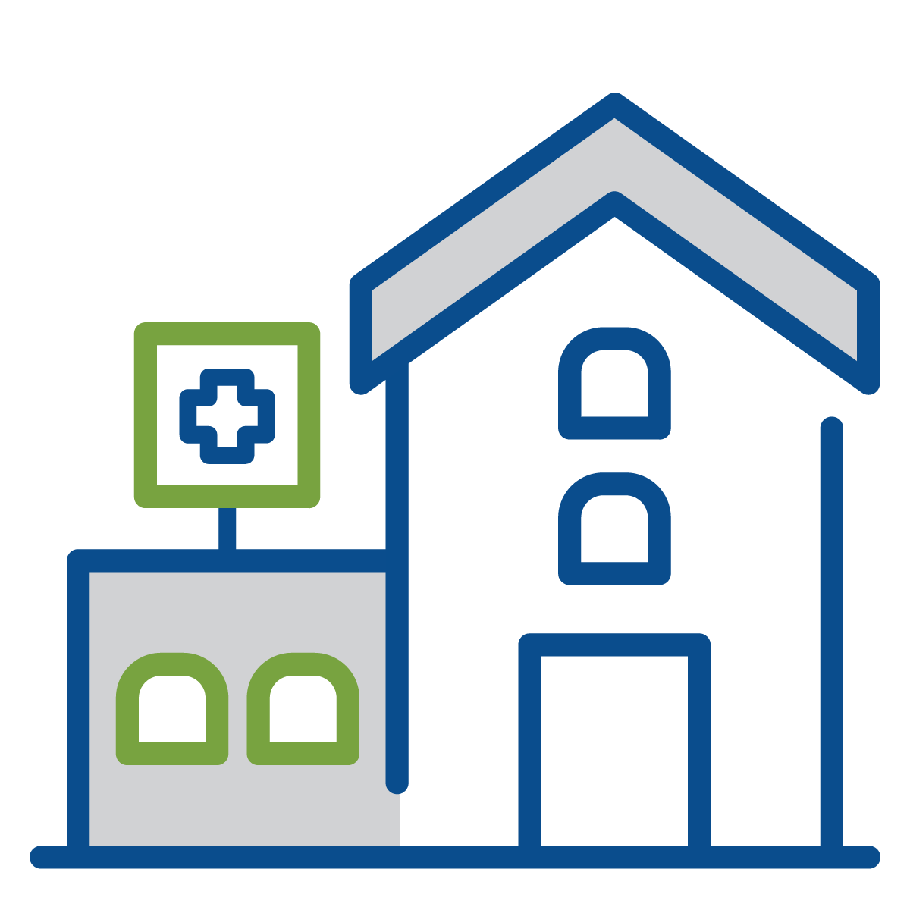
Step 3: Our Center
- We follow nationally recommended best practices to keep our centers clean and safe.
- Only EPA-registered cleaning products are used, and waiting areas are cleaned at least twice a day. This includes high touch surfaces such as chair arms, doorknobs, tabletops, countertops, handles, sinks and faucets.
- We clean every treatment room both before and after every patient. In addition, we clean all of our public areas throughout the day and are minimizing traffic in those areas.
- Tissues and sanitizer will be available near the front desk.

